**AI-DRIVEN EXPLORATION AND PREDICTION OF COMPANY REGISTRATION TRENDS**

**Phase 3 Team member**

**Name : Vallarasu S,**

**Dept : CSE-III year,**

**Domain : AI101(IBM- Artificial Group2),**

**Team Name : AI DRIVEN ,**

**College :SRG Engineering College**

**Introduction:**

This project leverages AI to predict future company registration trends, revolutionizing strategic decision-making. Utilizing advanced AI techniques like ensemble methods and deep learning enhances prediction accuracy, fostering a data-driven approach in understanding registrations.

#Import the libraries

import pandas as pd

import numpy as np

#Load the given dataset

df=pd.read_csv('D:\Data_Gov_Tamil_Nadu.csv')

df.head()

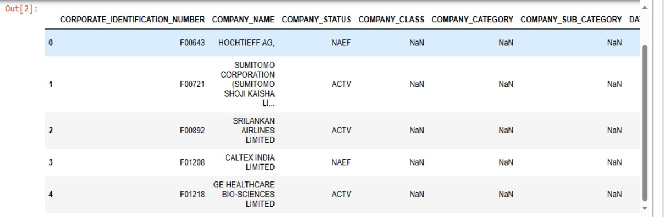

#Data preprocessing

#Check for missing values

df.isnull().sum()

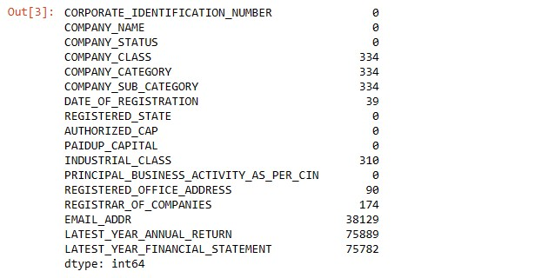

#Check for duplicate values

df.dropna(inplace=True)

#Remove the duplicate values

df.drop_duplicates(inplace=True)

#Again check the missing values are occur or not

df.isnull().sum()

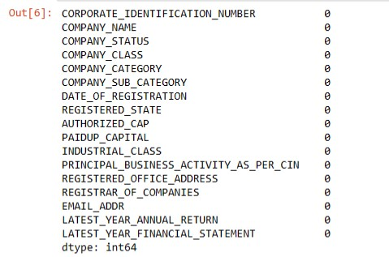

#Finally preprocessed data can be done successfully

df.head()

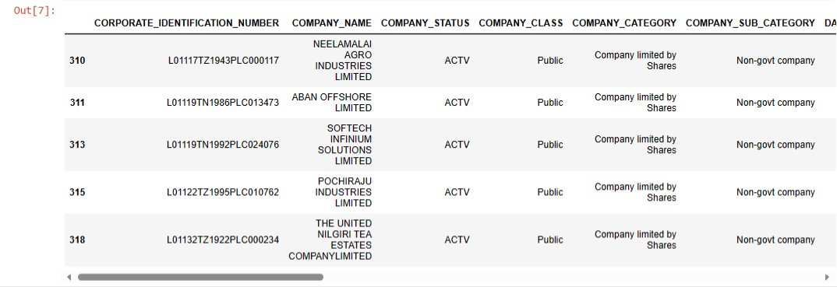

**Conclusion:**

Summarizes the project's key findings, achievements, and their significance. It provides a concise wrap-up, highlighting the project's impact and the knowledge gained during its development